Build Data Dashboards

(YouTube Data)

* Insight 1: Which state in the US has the most likes, provided its views are 10,000,000,000 or more?

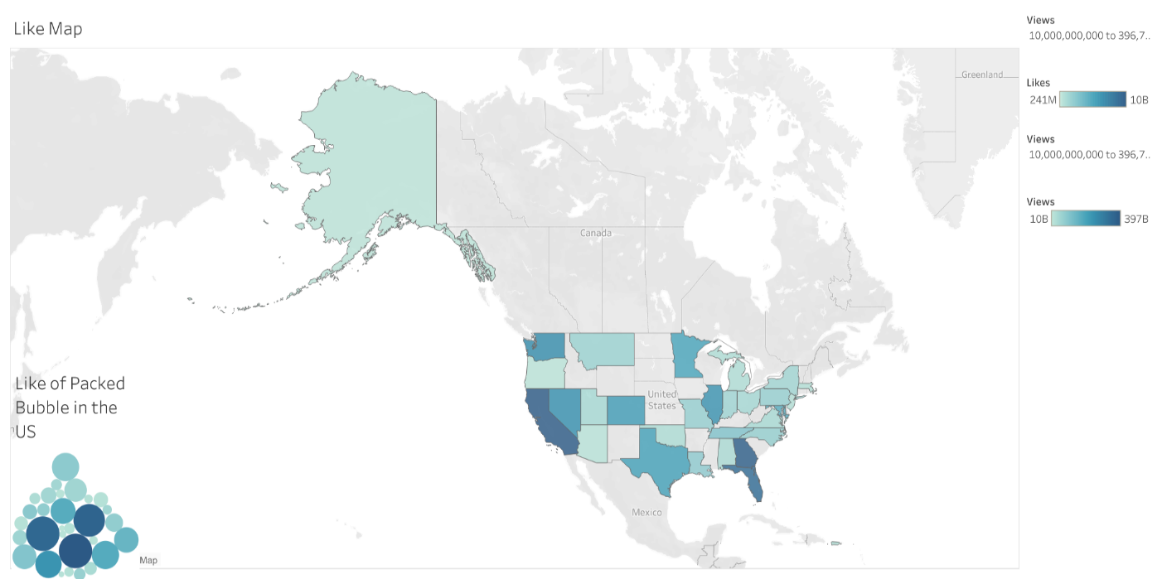 Link: [Like Dashboard](https://public.tableau.com/views/LikeDashboard/LikeDashboard?:language=en-US&:display_count=n&:origin=viz_share_link)

* Summary: According to this dashboard, the USA states with the most likes can be located smoothly, provided that the number of views is more than 10,000,000,000. As “CA” represented the most significant number of likes with 9,668,832,035, this is the greatest figure of likes from the selected data set. We can explore a more extensive range by going to the filter feature and expanding or narrowing the size of the range, which in our case starts from above ten billion to the end of the data set. Regarding the intensity of colours, the higher the density, the more likes, the lower the density, the fewer likes. Furthermore, I set the colours to suit colour blind folk.
* Design Comment: I preferred to go with a map chart because I am working with geographic data, as I see it as the best way to represent my data. To reinforce this, I used the Packed Bubbles Chart To make it simpler and more informative. I used a filter for the views because my insight was conditional on exceeding ten billion views, making it more appropriate to the sense.
* Resources: N/A
* Insight 2: Which category has the most views in AK state? 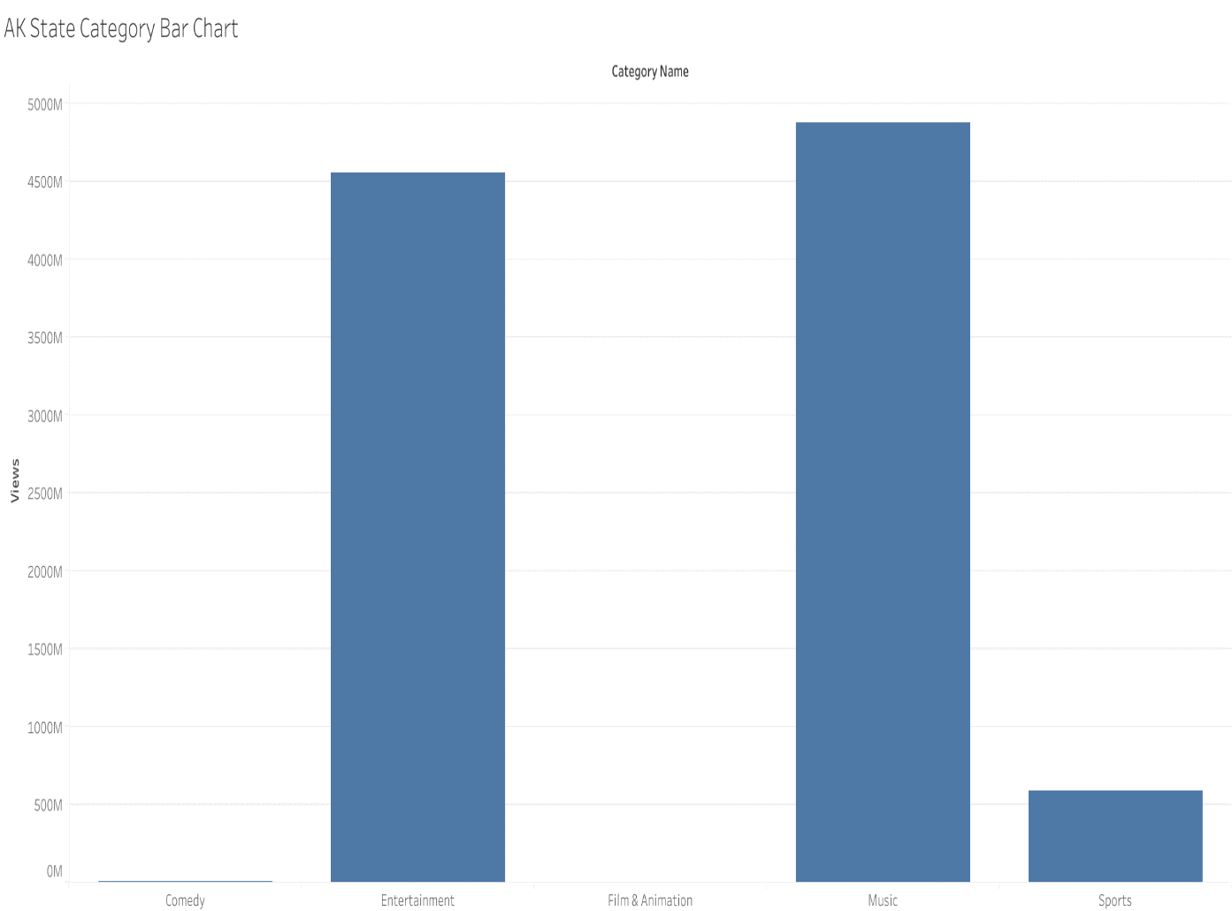
* Link: [AK State Category Bar Chart](https://public.tableau.com/views/AKStateCategoryBar/AKStateCategoryBar?:language=en-US&:display_count=n&:origin=viz_share_link)
* Summary: The Bar Chart depict the number views on different types of category. The categorical feature is plotted on the horizontal axis, and each bar height corresponds to the number of views made under each category type. We can see from this chart that three bars achieve an overwhelming superiority over the rest, where music, entertainment and sports made about 5B, 4.5B and nearly 600M, respectively. On the other hand, comedy and film & animation were also doing good by around 5.5M and 3.1M respectively. However, both were dwarfed by the overwhelming numbers of the three top categories mentioned above.
* Design Comment:  Here I have comparative data that I would like to represent through a chart then a bar chart would be the best option. This type of chart is one of the most familiar options as it is easy to interpret. This chart helps display data that is classified into nominal or ordinal categories.
* Resources: [Chart Blocks](https://www.chartblocks.com)
* Insight 3: Which channel has the most comments?

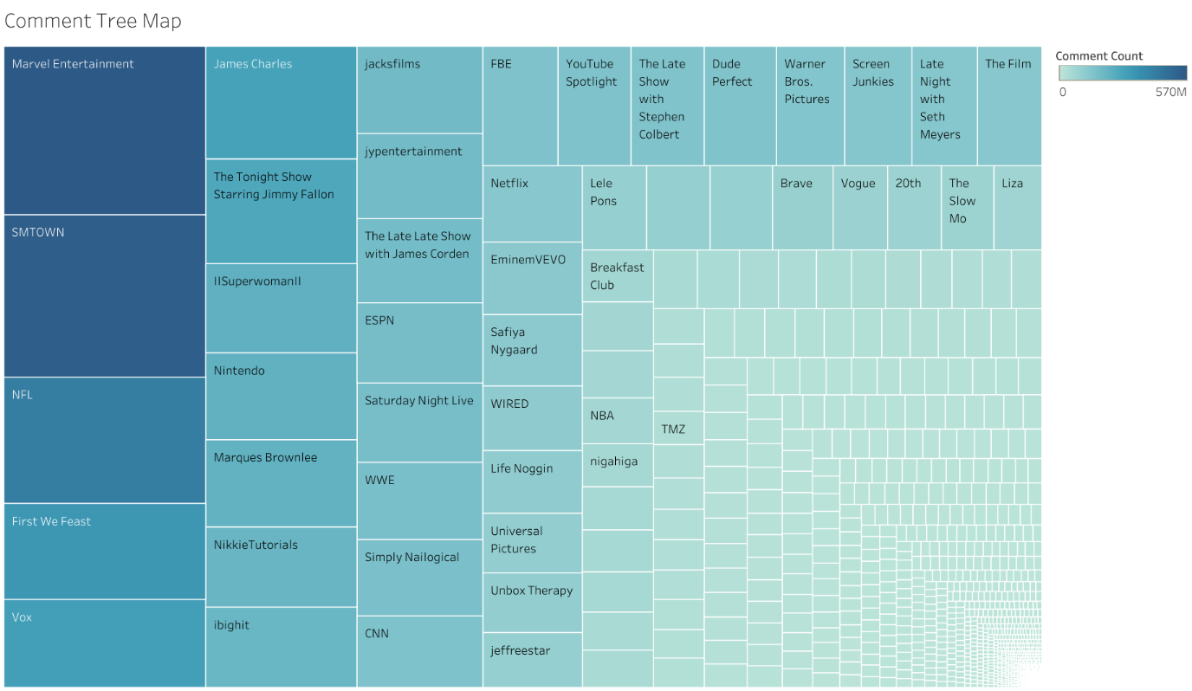

* Link: [Comment TreeMap](https://public.tableau.com/views/CommentTreeMap/CommentTreeMap?:language=en-US&:display_count=n&:origin=viz_share_link)
* Summary: I can make a few general conclusions from this visual: three channels (Marvel Entertainment, SMTOWN, and NFL) are roughly leading the comments activity (visually estimated based on the size of the rectangles & the density of the colour). Moreover, these same three are also different in terms of comments figures (estimated based on the numbers when we hover over the channel on the rectangles). What if I asked you which are the top 10 channels that achieved more comments? Alternatively, what is the exact difference between Channel A and B? We can see how easily a TreeMap breaks down when making these comparisons. I would argue that this visual work well in an exploratory phase of analysis, where the analyst can sort through the data to find what might be interesting to stakeholders. However, it doesn’t work so well when communicating what’s interesting in this data. Here is where other charts come in handy such as the bar chart (that I illustrated in the previous example) and many others.
* Design Comment: I designed the TreeMap to visualize the data in a hierarchical, tree-structured diagram where the size of the rectangles is organized from largest to smallest, where the larger rectangle indicates more comments and vice versa. Colour is compatible with the size, as the more it goes to dark blue, the higher the number of the comments, and the more it goes to light blue, the smaller it is, in perfect harmony with the size. I used the TreeMap Particularly because I want to visualize a part-to-whole relationship amongst many channels.

Resources: [Storytelling with data](https://www.storytellingwithdata.com/)

With Best Regards

Hussam Alharbi